
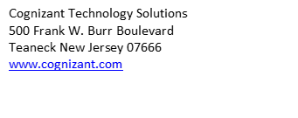​​
​
​
​
​
​Carrier CONFIDENTIAL
​
​
​Carrier GCP - LOW LEVEL DESIGN
​
​
​
​
​
​Table of Contents​

​​Contents
​
​
​
​
​
​
​
​
​
​
​
​
​
​
​
​
​
​
​
​
​
​
​
​
​
​
​
​
​
​
​
​
​
​
​
​
​
​​

- DOCUMENT HISTORY, VERSION, AND AUTHORS
Paper copies are valid only on the day they are printed. Refer to the author of the document to confirm the currency of this document.
- DOCUMENT VERSION AND AUTHORS
Date | Version | Name | Role | Comments
12/16/2025 | 1.0 | Vijayakumar Jayaseelan | Google Cloud Architect | Initial Draft based on Carrier LLD v0.1
- Version History
- COGNIZANT APPROVALS
Approval Date | Version | Name | Role
- Cognizant Approvals

- TRADEMARKS, DEFINITIONS AND ACRONYMS
Disclaimer: Systems or products mentioned in this document may not bear the trademarks of their Vendors or Owners. Herein, it is acknowledged that all the trademarks are the property of their respective owners. It is also acknowledged that there is no intention of breaching anybody’s copyrights, if there are extractions from any vendors’ documents.
- TRADEMARKS
Brand of Product | Description | Company
GCP | Google Cloud Console | Google Inc
Palo Alto | Palo Alto VM’s Firewall | Palo Alto
Blue Cat | IPAM | Blue Cat
- Trademarks
- ACRONYMS, ABBREVIATIONS, TERMS AND DEFINITIONS
Abbreviation | Definition | Abbreviation | Definition
GCP | Google Cloud Platform | NCC | Network Connectivity Center
VPC | Virtual Private Network | NSI | Network Security Integration
ILB | Internal Load Balancer | PSC | Private Service Connect
DNS | Domain Name System | IPAM | IP Address Management
SD-WAN | Software-Defined WAN | RA | Router Appliance
MIG | Managed Instance Group | TDD | Technical Design Document
LLD | Low Level Document
- Abbreviations
- DOCUMENT PURPOSE AND EXECUTIVE SUMMARY

- DESIGN OBJECTIVES AND SCOPE
The purpose of this document is to detail the implementation specifications for the Carrier Google Cloud network foundation. This Low-Level Design (LLD) translates the architectural requirements defined in the TDD into specific configuration parameters.
- IN SCOPE
The scope of this design includes:
- Network Connectivity Center (NCC): Implementation of a global Mesh topology for transitivity between SD-WAN and Workload VPCs. With Shared Host project and Transit project for communication
- Network Security Integration (NSI): In-band traffic inspection using Palo Alto Networks VM-Series firewalls which are scalable with internal Load Balancer.
- DNS & IPAM: Centralized management using BlueCat for global resolution. Create and configured BlueCat VM’s in GCP.
- Hub-and-Spoke Architecture: Deployment of Shared VPCs (M1P, M1NP, M3P, M3NP) to separate governance from agility.
- OUT OF SCOPE AND EXCLUSIONS
- Application-level configuration beyond the network foundation.
- Physical on-premises networking equipment configuration (outside of the SD-WAN hand-off).
- GCP application Landing Zone setup (where the applications will reside).
- GCP cloud native security solutions including AD integration, Identity Management, Secrets Management, Encryption
- On-premises and other CSPs (AWS, Azure, etc.)
- Google Cloud Security configuration and updates
- Palo Alto Security Configuration
- Third party solutions, tools and licenses
- Any application and data migration
- Application and data support
- Performance testing, User acceptance testing and Disaster Recovery Testing
- REQUIREMENTS

- FUNCTIONAL REQUIREMENTS
The table below lists the functional requirements pertinent to the scope of the Low-level design. Please note that business requirements become functional or non-functional requirements in low level design and there is no separate section for business requirements. As many systems provide hundreds or thousands of functions, the items in the functional requirement table are the most important features that require design configuration items or are typically related to integration and operational excellence.

FR ID | Requirement | Pertinent Design Component
FR - 01 | Global Transitivity | NCC Mesh topology allows all spokes to communicate with all other spokes.
FR-02 | Traffic Inspection | In-band NSI intercepts traffic at the vNIC and forwards it to Palo Alto firewalls in the global-security-project.
FR - 03 | Hybrid Connectivity | Cisco SD-WAN appliances in global-transit-project inject On-Prem routes into the Mesh.
FR - 04 | DNS Resolution | All Workload VPCs forward DNS queries to BlueCat resolvers in the Transit VPC.
FR - 05 | Private Service Access | Dedicated global-m1psc-project hosts Private Service Connect (PSC) endpoints.
- Functional Requirements
- NON-FUNCTIONAL REQUIREMENTS
This table lists the non-functional requirements pertinent to the scope of the low-level design in the system. All secondary functions of the system are tabulated in this section. These non-functional requirements should not affect the functional nature of the scope of this low-level design. Example: a system should be operation hardened or not hardened. A system should operate with or without anti-malware. Administrative security controls do not affect the functionality of scope.

NFR ID | Requirement | Pertinent Design Component
NFR-01 | Scalability | Palo Alto fleet uses Regional Managed Instance Groups (MIGs) that scale based on throughput.
NFR-02 | High Availability | Cisco Catalyst 8000V appliances are deployed with 2 per region for HA.
NFR-03 | Governance | Shared VPC model centralizes network administration while allowing workload agility.
- Non-Functional Requirements
- ARCHITECTURAL DESIGN DECISIONS

This section documents the key decisions made while preparing the design from the architecture perspective. Each of the design decisions taken to arrive at the final solution is documented under this section.
Decision ID | Design Decision Description | Rational & Justification
AD-01
- Architectural Design Decisions

- DETAILED DESIGN
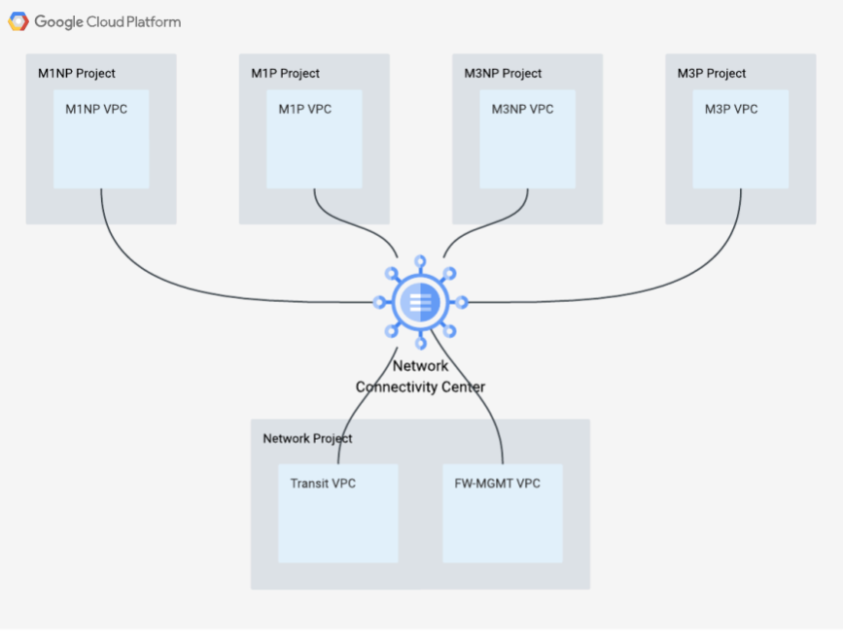
- NCC architecture and traffic flow
- SOLUTION ARCHITECTURE
The architecture utilizes a Tiered Shared VPC model anchored by a single global Network Connectivity Center (NCC) Hub. This Hub manages connectivity between Workload VPCs (Spokes) and the SD-WAN overlay (Router Appliance Spokes) with Cloud router in transit spoke
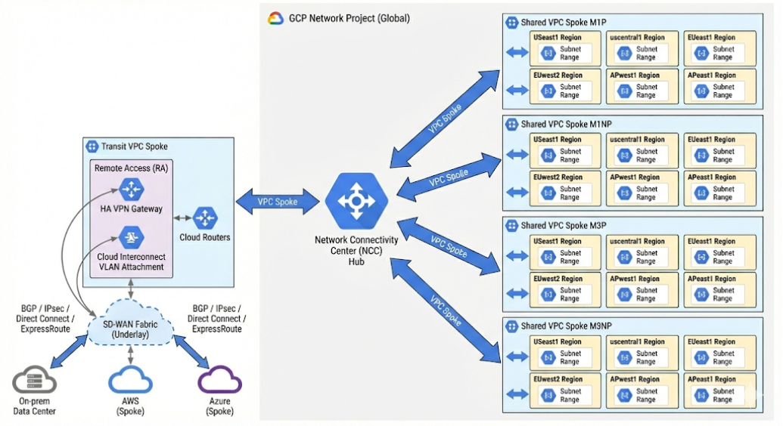
- NCC architecture and traffic flow
- DETAILED DESIGN—LOGICAL
Hub Configuration:
- Host Project: global-network-project
- Hub Name: global-carrier-hub
- Topology: Mesh (All spokes can communicate subject to NSI policy).
Spoke Configuration: The following VPCs are registered as spokes to the global-carrier-hub:
Spoke Name | Attached VPC | Project | Regions | Description
spoke-m1p | global-host-Model-vpc | global-ncc-hub | All 6 Regions | Model 1 Production Workloads
spoke-m1np | global-host-Model-vpc | global-ncc-hub | All 6 Regions | Model 1 Non-Prod Workloads
spoke-m3p | global-host-Model-vpc | global-ncc-hub | All 6 Regions | Model 3 Production Workloads
spoke-m3np | global-host-Model-vpc | global-ncc-hub | All 6 Regions | Model 3 Non-Prod Workloads
Transit Spoke | global-transit-vpc | network-transit | Global | Hosts SD-WAN RAs & BlueCat DNS & FWMGMT
- Spoke table
- GOOGLE CLOUD RESOURCES

- PROJECT STRUCTURE

Project ID | Resource Role | VPC Name | Brief Description
global-ncc-hub | NCC Hub |  | Dedicated project for NCC Hub resource.
shared-services | Connectivity Spoke | 1) global-host-M1P -vpc,  2) global-host-M1NP-vpc,  3) global-host-M3P- vpc,  4) global-host-M3NP-vpc, | Shared Host project, where the subnets are connected to shared project
network-transit | Connectivity Spoke | global-transit-vpc | Hosts Router Appliance, Cloud Router & BlueCat.
network-security | Security Data  Security Management | global-security-vpc-data,  global-security-vpc-mgmt | 1) Hosts Palo Alto VM-Series & ILBs  2) Hosts Stratacom interfaces & FW management.
shared-host-pvpc | PSC Host | global-shared-svcs-vpc | Host for Private Service Connect endpoints.

- SUBNET & IP CONFIGURATION
Subnets are allocated from regional /16 blocks. Specific /24 ranges are assigned by BlueCat IPAM.
The region, BU & APP will be automated using terraform script
Shared VPC Project | Subnet Name | Region | CIDR Block | Purpose
M1P-shared-vpc | $region(us-e4)-m1p-$BU-$APP-subnet1 | us-east4 | 10.150.0.0/16 | Workload
 | $region(us-c1)-m1p-$BU-$APP-subnet1 | us-central1 | 10.100.0.0/16 | Workload
 | $region(eu-w3)-m1p-$BU-$APP-subnet1 | europe-west3 | 10.173.0.0/16 | Workload
 | $region(eu-w1)-m1p-$BU-$APP-subnet1 | europe-west1 | 10.177.0.0/16 | Workload
 | $region(ap-se4)-m1p-$BU-$APP-subnet1 | asia-southeast1 | 10.109.0.0/16 | Workload
 | $region(ap-e4)-m1p-$BU-$APP-subnet1 | asia-east2 | 10.115.0.0/16 | Workload
M1NP-shared-vpc | $region(us-e4)-m1np-$BU-$APP-subnet1 | us-east4 | 10.151.0.0/16 | Workload
 | $region(us-c1)-m1np-$BU-$APP-subnet1 | us-central1 | 10.101.0.0/16 | Workload
 | $region(eu-w3)-m1np-$BU-$APP-subnet1 | europe-west3 | 10.174.0.0/16 | Workload
 | $region(eu-w1)-m1np-$BU-$APP-subnet1 | europe-west1 | 10.178.0.0/16 | Workload
 | $region(ap-se4)-m1np-$BU-$APP-subnet1 | asia-southeast1 | 10.110.0.0/16 | Workload
 | $region(ap-e4)-m1np-$BU-$APP-subnet1 | asia-east2 | 10.116.0.0/16 | Workload
M3P-shared-vpc | $region(us-e4)-m3p-$BU-$APP-subnet1 | us-east4 | 10.152.0.0/16 | Workload
 | $region(us-c1)-m3p-$BU-$APP-subnet1 | us-central1 | 10.102.0.0/16 | Workload
 | $region(eu-w3)-m3p-$BU-$APP-subnet1 | europe-west3 | 10.175.0.0/17 | Workload
 | $region(eu-w1)-m3p-$BU-$APP-subnet1 | europe-west1 | 10.179.0.0/17 | Workload
 | $region(ap-se4)-m3p-$BU-$APP-subnet1 | asia-southeast1 | 10.111.0.0/17 | Workload
 | $region(ap-e4)-m3p-$BU-$APP-subnet1 | asia-east2 | 10.117.0.0/17 | Workload
M3NP-shared-host | $region(us-e4)-m3p-$BU-$APP-subnet1 | us-east4 | 10.153.0.0/16 | Workload
 | $region(us-c1)-m3np-$BU-$APP-subnet1 | us-central1 | 10.103.0.0/16 | Workload
 | $region(eu-w3)-m3np-$BU-$APP-subnet1 | europe-west3 | 10.175.128.0/17 | Workload
 | $region(eu-w1)-m3np-$BU-$APP-subnet1 | europe-west1 | 10.179.128.0/17 | Workload
 | $region(ap-se4)-m3np-$BU-$APP-subnet1 | asia-southeast1 | 10.111.0.0/17 | Workload
 | $region(ap-e4)-m3np-$BU-$APP-subnet1 | asia-east2 | 10.117.128.0/17 | Workload

- SHARED SERVICES SUBNETS details

VPC | US-East4 | US-Central1 | EU-West1 | EU-West3 | AP-East1 | AP-SouthEast1
global-transit-vpc | 10.154.0.0/24 | 10.154.1.0/24 | 10.154.2.0/24 | 10.154.3.0/24 | 10.154.4.0/24 | 10.154.5.0/24
global-security-vpc-data | 10.154.8.0/24 | 10.154.9.0/24 | 10.154.10.0/24 | 10.154.11.0/24 | 10.154.12.0/24 | 10.154.13.0/24
global-security-vpc-mgmt | 10.154.16.0/24 | 10.154.17.0/24 | 10.154.18.0/24 | 10.154.19.0/24 | 10.154.20.0/24 | 10.154.21.0/24
global-shared-svcs-vpc | 10.154.32.0/24 | 10.154.33.0/24 | 10.154.34.0/24 | 10.154.35.0/24 | 10.154.36.0/24 | 10.154.37.0/24

- Shared Services Subnet Details
- SYSTEM INTEGRATION
- NETWORK SECURITY INTEGRATION (NSI)
Traffic inspection is enforced via In-band NSI, transparently intercepting traffic at the hypervisor level.
- Inspection Model: Centralized Fleet (NSI Producer) in global-security-project(network-security).
- Enforcement Point: Palo Alto VM-Series (Layer 3-7 inspection).
- Encapsulation: Geneve encapsulation is used to forward packets to the NSI Endpoint.
- DESIGN

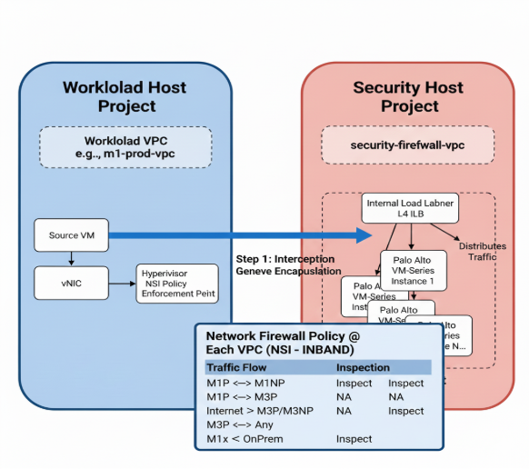
- FIREWALL POLICY MATRIX

Source | Destination | Action
M1P | M1NP | Inspect
M1P | M3P | Inspect
M1P | M3NP | Inspect
M1P | M1P | NA (Intra-VPC)
M1NP | M1NP | NA (Intra-VPC)
M1NP | M3P | Inspect
M1NP | M3NP | Inspect
M3P | ANY | Inspect
M3P | ANY | Inspect
M1X | On-Prem | NA (Intra-VPC)
Internet | M3P/M3NP | NA (Intra-VPC)
- Firewall Policy Matrix
- Palo Alto FLEET CONFIGURATION

- Deployment: Regional Managed Instance Groups (MIGs).
- Interfaces:
- nic0 Data Plane(ingress/egress traffic) attached to security-vpc(global-security-vpc-data),
- nic1(Management Plane attached to global-security-vpc-mgmt vpc).
- Load Balancing: Internal Load Balancers (ILB) distribute traffic to the firewall fleet.

- NSI POLICY WORKFLOW
The NSI policy is applied in the Spoke VPCs (M1P, M3P, etc.) but references the Service Producer.
- Interception: Traffic from a Model 1 VM (e.g., 10.164.1.5) destined for On-Prem (10.0.0.0/8) is intercepted at the hypervisor.
- Encapsulation: The packet is encapsulated (Geneve) and sent to the NSI Endpoint (Palo Alto ILB) in global-security-project.
- Inspection: Palo Alto inspects L3-L7.
- If Allowed: Packet is returned to the Spoke VPC and routed to the Transit VPC (SD-WAN).
- If Denied: Packet is dropped and logged.
- FIREWALL MANAGEMENT
- VPC: global-security-vpc-mgmt
- Component: StrataCom
- Connectivity: Reached via VPC Peering or PSC from the global-security-project.
- DNS ARCHITECTURE (BLUECAT)
BlueCat DNS serves as the central resolver, hosted in the global-transit-project.
- Reachability: Accessible from On-Prem (via SD-WAN) and Cloud VPCs (via NCC Mesh).
- Forwarding: Google Cloud DNS in Workload VPCs is configured with an Outbound Forwarding Zone pointing to the BlueCat ILB.
- Placement: BlueCat resolvers reside in the transit-vpc.

- Deployment Details
- Hosting Project: global-transit-project (aligned with TDD "Transit VPC" placement).
- Reachability:
- From Workloads (M1/M3): Workload VPCs route DNS queries to the BlueCat VIP advertised via the NCC Mesh.
- From On-Premises: Reachable via the Cisco SD-WAN RAs in the same VPC.
- From AWS: BlueCat Address Manager (Management/Control plane) is deployed in AWS. BAM will be reachable via required TCP/UDP ports via Cisco SD-WAN RAs in the same VPC.
- Forwarding: Google Cloud DNS in Workload VPCs will be configured with an Outbound Forwarding Zone pointing to the BlueCat Internal Load Balancer IP.
- BlueCat- high level integration flow
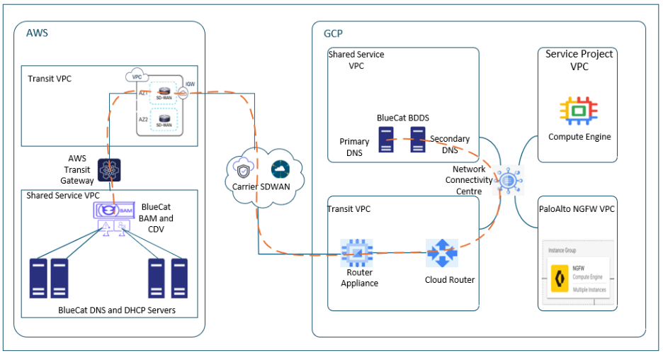

- BlueCat DNS Architecture
- Placement: BlueCat DNS resolvers are deployed in the global-transit-project (Transit VPC).
- Reachability: All Spoke VPCs (M1/M3/Shared) reach BlueCat via the NCC Mesh.
- Configuration:
- Cloud DNS: Configured in Spoke VPCs with an inbound/outbound forwarding policy.
- Forwarding: All DNS queries for on-prem zones or custom domains are forwarded to the BlueCat IP addresses in the transit-vpc.
- BlueCat Integration with Apigee, Terraform and GitHub

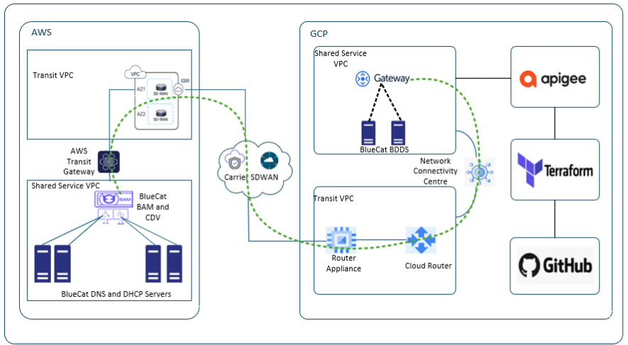

To achieve a fully automated DNS/IPAM workflow in GCP, BlueCat components will be integrated with Terraform and GitHub, with Apigee acting as the API management layer.
- BlueCat Gateway will be deployed in GCP and configured to communicate with BlueCat Address Manager (BAM) in AWS and BDDS in GCP via secure APIs.
- All external API calls, including those initiated by Terraform and CI/CD pipelines from GitHub, will route through Apigee. Apigee provides:
- Authentication and Authorization
- Traffic Management (rate limiting, quotas)
- Security Policies (threat protection, schema validation)
- Analytics and Monitoring
- Terraform will use the BlueCat Terraform Provider, pointing to the Apigee proxy URL for Gateway APIs. This enables Infrastructure-as-Code automation for IP allocation/DNS record creations.
- GitHub will be leveraged for CI/CD workflows:
- Trigger Terraform plans and applies.
- Manage Apigee proxy configurations and policy updates.
- The integration ensures:
- Centralized API governance via Apigee.
- Automated provisioning and configuration through Terraform.
- Version-controlled workflows and pipeline automation via GitHub.
- MONITORING AND SCALABILITY
Details of Monitoring and Scalability are below:
- SCALABILITY MANAGEMENT
- Palo Alto Firewalls: Triggered by throughput metrics, utilizing Regional Managed Instance Groups (MIGs).
- IP Addressing: global-shared-svcs-project subnets are carved from a dedicated /16 block to support growth.
- MONITORING
Tooling:
- Network Intelligence Center is enabled for deep visibility into network performance and topology.

- DOCUMENTS REFERENCED

Document Name | Brief Description
Carrier Cloud Foundation Network TDD v0.1 | Technical Design Document serving as the basis for this LLD.
BlueCat IPAM Design | IP Addressing Standards and Allocations.
Palo Alto NSI Implementation Guide | Configuration guide for VM-Series on GCP.
- Reference Documents

